Creating Microservices for account and loan

AccountController Code:

**package** com.cognizant.account.controller;

**import** org.springframework.web.bind.annotation.*;

**import** java.util.HashMap;

**import** java.util.Map;

@RestController

@RequestMapping("/accounts")

**public** **class** AccountController {

@GetMapping("/{number}")

**public** Map<String, Object> getAccountDetails(@PathVariable String number) {

Map<String, Object> response = **new** HashMap<>();

response.put("number", number);

response.put("type", "savings");

response.put("balance", 234343);

**return** response;

}

}

Output:

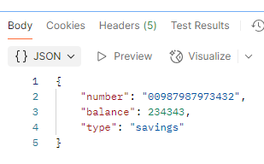

LoanController Code:

**package** com.cognizant.loan.controller;

**import** org.springframework.web.bind.annotation.*;

**import** java.util.HashMap;

**import** java.util.Map;

@RestController

@RequestMapping("/loans")

**public** **class** LoanController {

@GetMapping("/{number}")

**public** Map<String, Object> getLoanDetails(@PathVariable String number) {

Map<String, Object> response = **new** HashMap<>();

response.put("number", number);

response.put("type", "car");

response.put("loan", 400000);

response.put("emi", 3258);

response.put("tenure", 18);

**return** response;

}

}

Output:

